# Overview

## Screen Flow

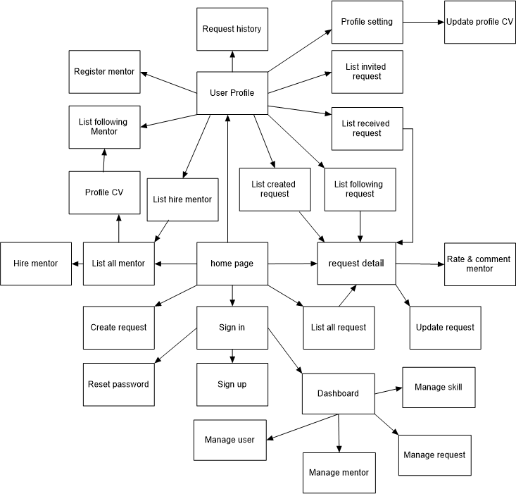

* 1. Database Scheme

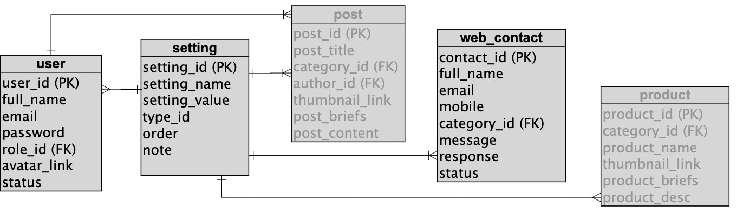

## Implementing Priorities

|  |  |
| --- | --- |
| **Priority** | **Screens (Prioritize from left to right)** |
| #1 | Home, User Register, User Login, Dashboard, Setting List, Setting Details |
| #2 | Reset Password, User Profile, User List, User Details, Web Contacts, Contact Info |
| #3 | Change Password, Product List, Product Details, Public Products, Product Info,  Post List, Post Details, Blog List, Blog Details, Authorization (Admin, Mkt, User) |

The layouts for some of the screens are defined in the Screen Layouts part below. Students to define the layouts for missing screens as well as the functionalities of all the screens.

# Screen Layouts

## Web Screens

* + 1. Home Page

Create a blank Home Page screen: with web footer integrated (this web footer would be developed as the scope of the Dashboard screen); the web header shown differently as below. The web header would be shown in all the pages.

(i) When user has not logged in (shown in the Web screens)



(2i) When user has logged in (shown in the Web screens)



(3i) When user has logged in (shown in the Admin screens)

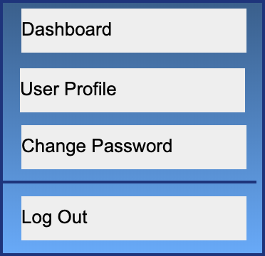In case the user hovers the avatar, below context menu would be shown, from there allow the user to access the relevant screens or to logout. After logging out, the user would be directed to the Home Page

* + 1. 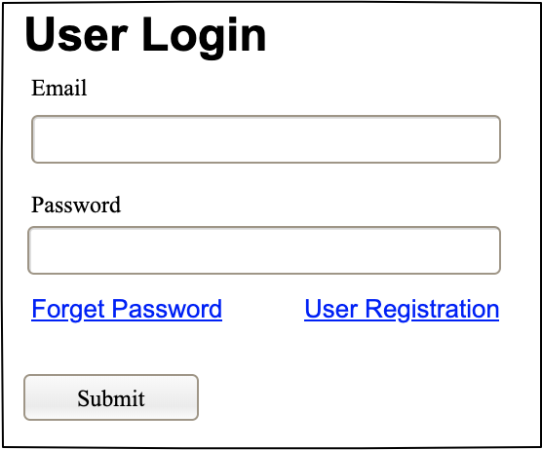User Login
    2. User Register

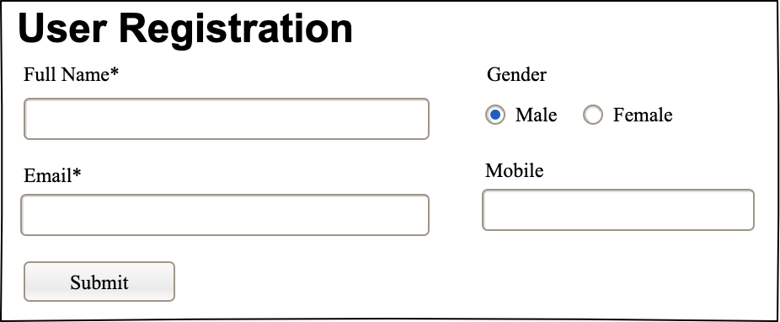After submit successfully the user registration, the user would receive an email from that he/she can click the link to verify the email before he/she can log in.

* + 1. Reset Password

By entering a valid email to reset password, the user would receive a link from that he/she can click to open a page for inputting new passwords. The link would be timeout in 30 minutes

|  |  |
| --- | --- |
|  |  |

* + 1. 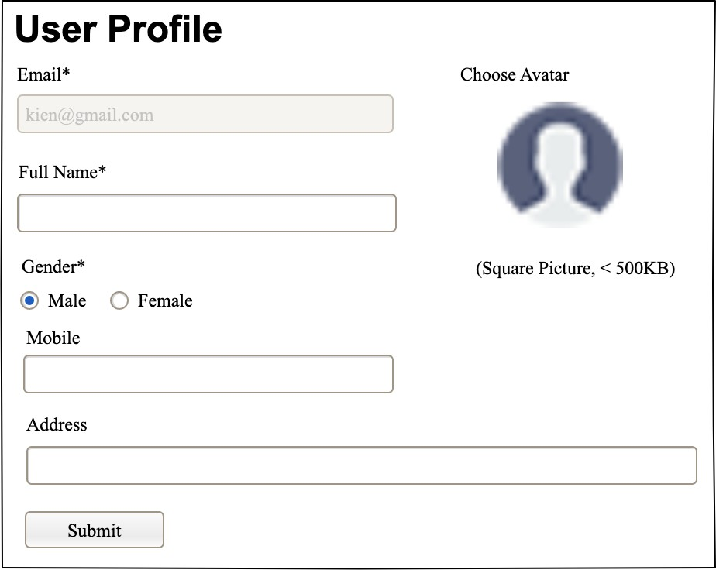User Profile
    2. Change Password

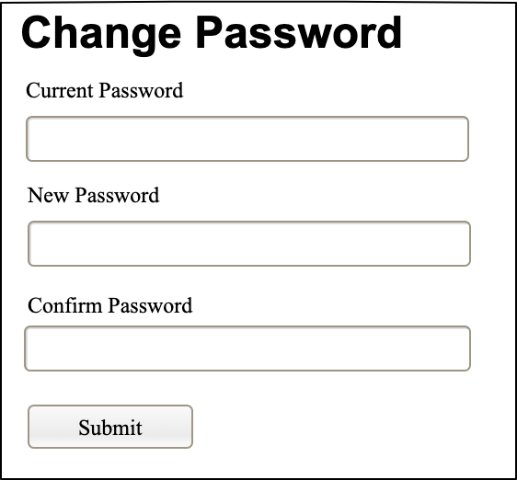

## Admin Screens

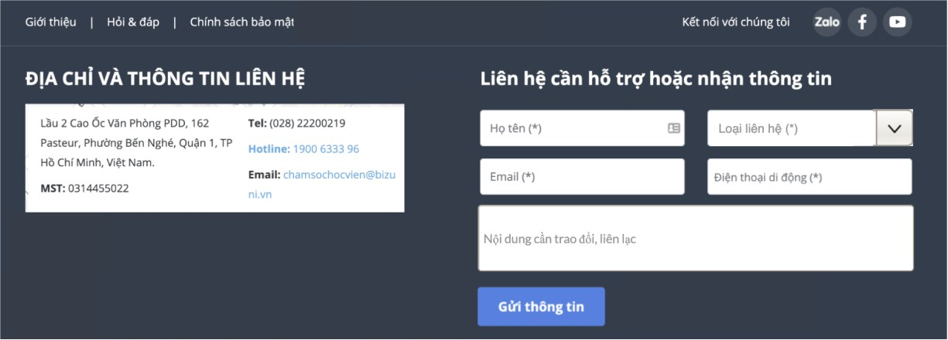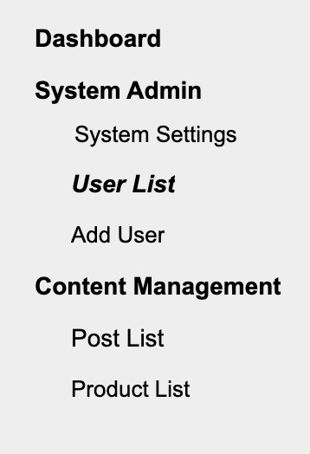

* + 1. Dashboard

Create a blank Home Page screen with

* + - * Web header integrated (this web header would be developed as the scope of the Home Page screen). The web header would be shown in all the pages.
      * Sider Menu: shown in the left sider of all the admin pages. This is a tree menu from which allow user to choose to access relevant Admin screen
      * Web footer: the layout of the web footer is as below. This would be developed as the scope of this Dashboard page and it would be included in all the pages
    1. Setting Management

1. *Setting List*

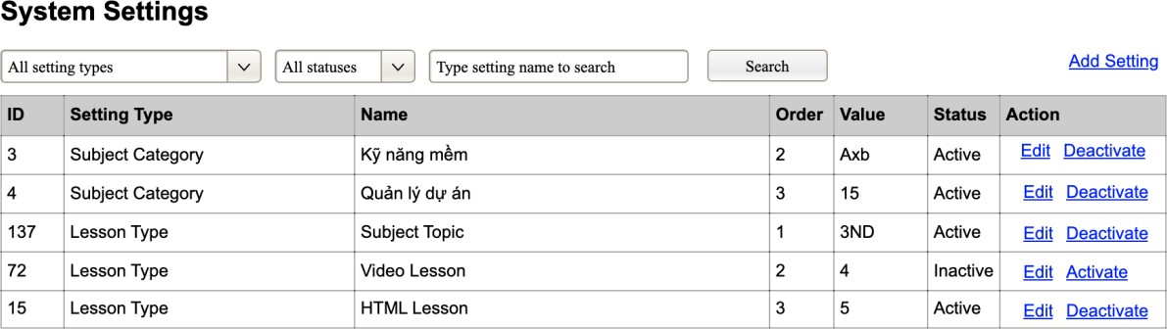

1. *Setting Details*

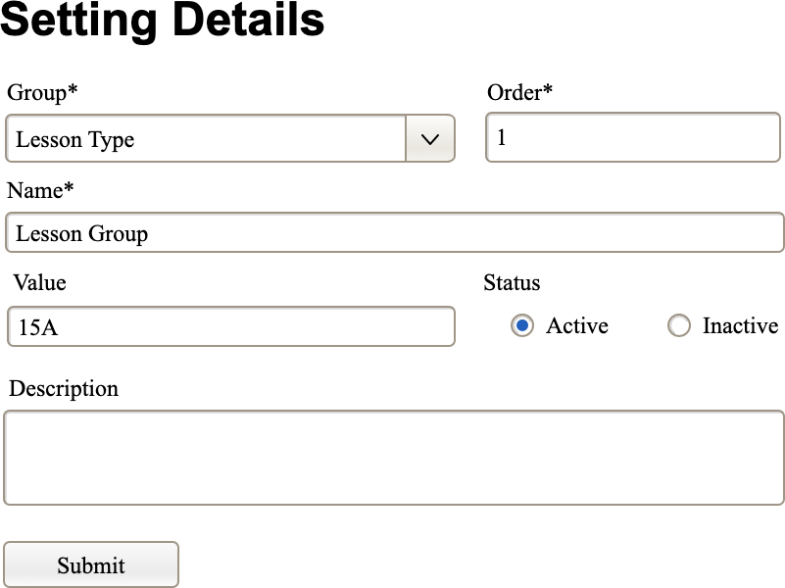

* + 1. User Management

1. *Users List*

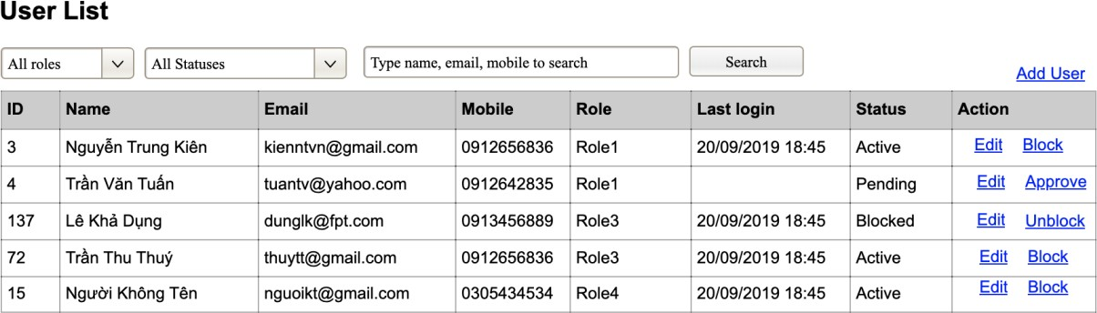

1. *User Details*

